FACULTY EVALUATION
Programme Name: SEP Scale Alumni Masterclass Module 1 Uganda (11th May 2026 - 15th May 2026)
Session: Reflection on leadership and teams (employees)
Faculty Name: Lenah Gachoki
No. of Respondents: 6
No. of Participants: 10
Evaluation Parameter | (%) Individual Score | (%) Programme Average
Punctuality (Commencement and Completion of Sessions) | 100 | 93
How well do you understand the core concepts presented? | 93 | 94
Rate your confidence in applying the new skills learnt | 80 | 87
Degree of Faculty preparedness for the sessions | 90 | 94
Content and methodology of the program | 97 | 94
Quality of class and group discussions | 87 | 88
The information presented in the course is relevant to my work (ministry) | 93 | 94
Average scores | 91 | 92

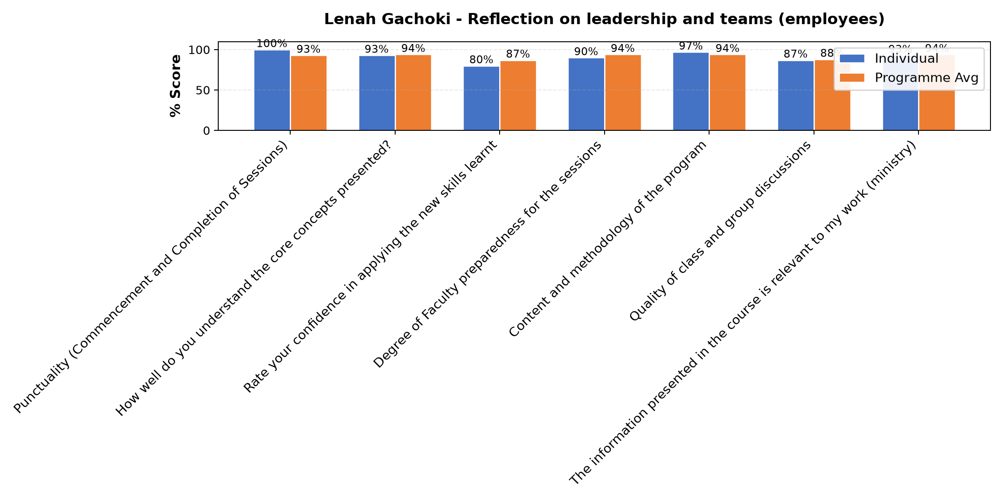

Comments & Feedback
- • I don't see any barriers. Am going to apply for the values learned
- • Lack of enough self knowledge
- • Maybe it's the moment of time.hunger and luck of self motivation
SUBMITTED THROUGH:
SBS Evaluation Automation System

